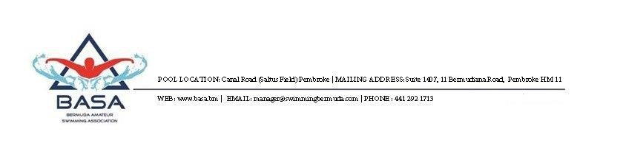

March 25, 2026

Department of Sport and Recreation
Craig Appin House
8 Wesley Street
Hamiton HM 11
Bermuda

Emma Harvey - Elite Athlete Assistance Program

The Bermuda Amateur Swimming Association (“BASA”) is the National Sports Governing Body for Aquatics. We confirm that Emma Harvey is a member in good standing of BASA.

Emma has clearly demonstrated commitment, promise and achievement in swimming. We refer you the supporting documents in her application. She is recognized as an elite athlete by the Bermuda Olympic Association. The applicant meets the stated goals and objectives of the Program.

Emma has broken 5 National Records over the past 12 months. BASA looks forward to supporting her ambitions at the Commonwealth Games, Pan Pacific Swimming Championship and the World SC World Championship.

Accordingly, BASA is providing this letter of endorsement to support Emma’s application.

Please contact us should you have any queries or require additional information.

Yours faithfully

Michael Harvey
President

